Chapter 9, Problem 71.

Obtain the equivalent impedance of the circuit in Fig. 9.78.

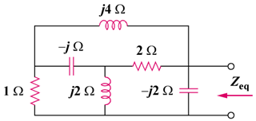

Figure 9.78
For Prob. 9.71.

